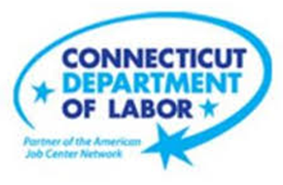

**NEW WEEKLY JOB POSTINGS FROM   
HELP WANTED ONLINE  
Office of Research**

**Week Ending December 18th, 2021: Weekly New Ads Rebound From a Three Month Low.**

WETHERSFIELD, December 23rd, 2021 – During the week ending December 18th, there were 9,040 new postings, up 2,156 new ads or +31% from a week ago. More than half of this overall increase occurred in Healthcare & Social Assistance, Retail Trade, and Educational Services, the three of which had respective increases of 654, 321, and 161. The most recent week of total new ads is a rebound from the prior week, which was the lowest level since August. New ads are up substantially from a year ago, which saw 3,863 during the week ending 12/19/20. The three occupations with the largest new ad increase over the week were Laborers and Material Movers (+244 new ads), Registered Nurses (+190 new ads), and Tractor-Trailer Truck Drivers (+105 new ads). Occupations with the largest over the week decreases were Real Estate Sales Agents (-54 new ads), Janitors and Cleaners (-20 new ads), and Retail Salespersons (-19 new ads). Employers with the largest over the week increase includes Hartford Healthcare (+494 new ads), Amazon (+310 new ads), and Avangrid (+103 new ads). The largest employer decreases occurred at Boehringer Ingelheim (-47 new ads), Verint Systems (-27 new ads), and Masonicare Corporation (-24 new ads).

**Industries** with the most new postings include Health Care & Social Assistance, Retail Trade, and Finance & Insurance.

**Occupations** with the most new postings include Registered Nurses, Laborers and Material Movers, and Wholesale & Manufacturing Sales Representatives.

**Employers** with the most new postings include Hartford Healthcare, Amazon, and Aya Healthcare.

**The three industries with the most new job postings where**

* **Health Care & Social Assistance** (2,312 new postings, +39% over the week)
* **Retail Trade** (1,010 new postings, +47% over the week)
* **Finance & Insurance** (620 new postings, +9% over the week)

  
 Sixteen sectors had job posting increases over the week and five had decreases. The increasing sectors grew by a combined 2,282 new ads and decreasing ones fell by a combined 126 new ads. Six industries grew by over 100 new ads over the week, the largest being Health Care and Social Assistance (+654 new ads), Retail Trade (+321 new ads), and Educational Services (-161 new ads). The most recent week of new ads was 332 ads higher than four weeks ago. The largest industry increase and decrease over four weeks occurred in Health Care & Social Assistance (+668 new ads) and Retail Trade (-122 new ads).  
  
 For more information on total job ads by industry for Connecticut and its labor market areas, see the monthly report available here: <https://www1.ctdol.state.ct.us/lmi/hwol.asp>

**New Job Postings by Occupation**



**The occupations with the most new postings were:**

* Registered Nurses (677 new postings, +39% over the week)
* Laborers, Freight, Stock and Material Movers (314 new postings, +349% over the week)
* Sale Representatives, Wholesale & Manufacturing (237 new postings, +41% over the week)

**Employers with the Most New Job Postings** 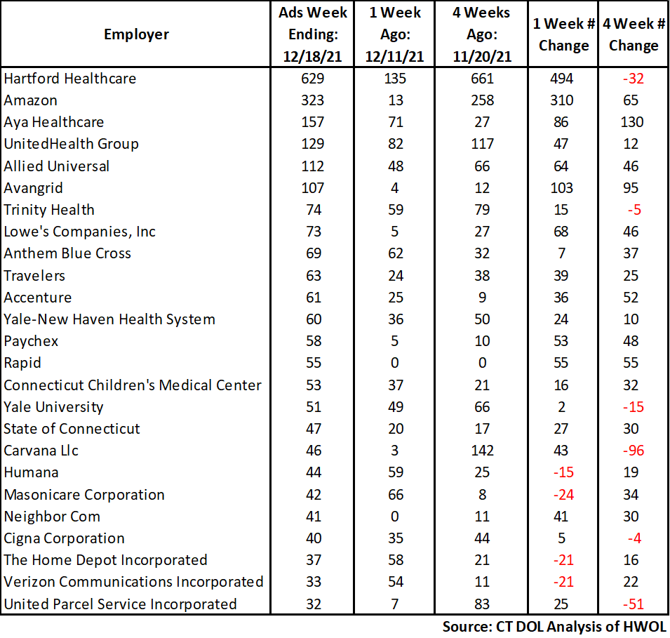

Employers with the most new job postings during the week were mostly in Health Care, Finance & Insurance, and Retail Trade. The 25 employers shown above account for 27 percent of all new ads. Among the top 25 employers, 21 had over the week ad increases and 4 had decreases. The 21 increasing employers had a combined 1,560 new ads, and the four decreasing employers in the top 25 fell by a combined 81 new ads. The three employers with the most ad had a combined 12.5% of total ads. Over four weeks, 19 employers in the above table had increases and 6 had decreases. The largest four-week increase occurred at Aya Healthcare (+130 new ads) and the largest decrease occurred at Carvana LLC (-96 new ads).

**What is HWOL?**The **Conference Board Help Wanted Online**® Data Series (HWOL) measures the number of new, first-time Online job postings and jobs reposted from the previous month for over 16,000 Internet job boards, corporate boards and smaller job sites that serve niche markets and smaller geographic areas. To view more HWOL data, go to: <https://www1.ctdol.state.ct.us/lmi/HWOL2021.pdf>